1)      Update the categoryName From “Beverages” to "Drinks" in the categories table.

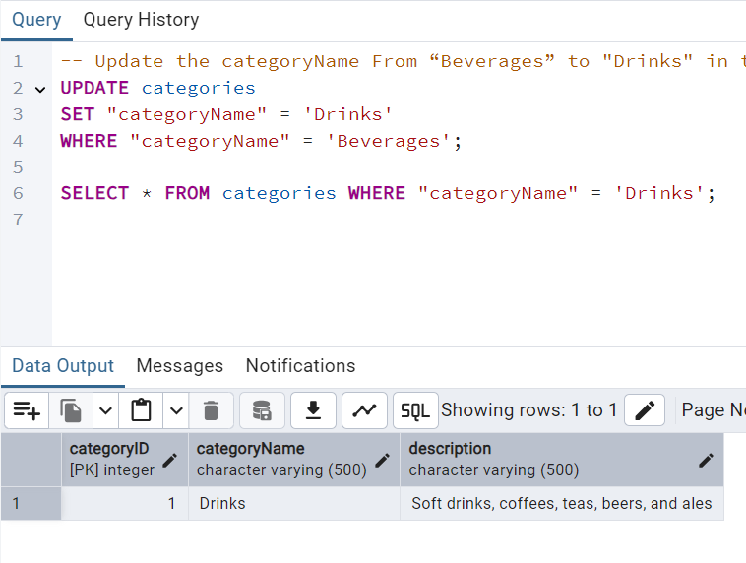

2)      Insert into shipper new record (give any values) Delete that new record from shippers table.

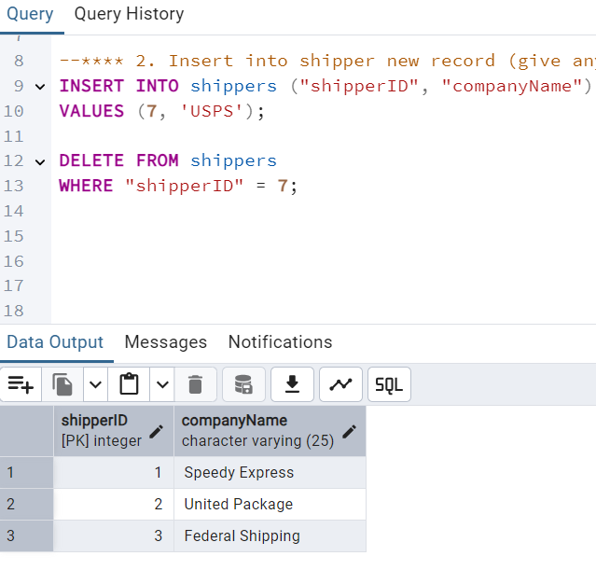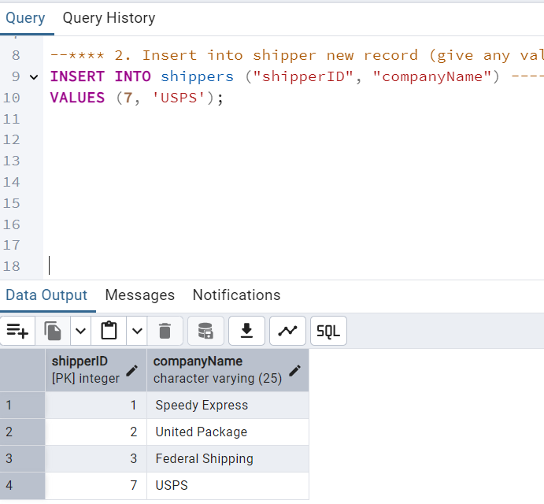

3)      Update categoryID=1 to categoryID=1001. Make sure related products update their categoryID too. Display the both category and products table to show the cascade.   
Delete the categoryID= “3”  from categories. Verify that the corresponding records are deleted automatically from products.  
 (HINT: Alter the foreign key on products(categoryID) to add ON UPDATE CASCADE, ON DELETE CASCADE)

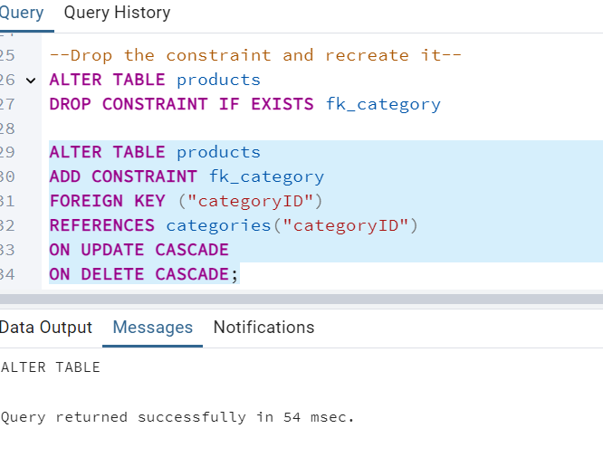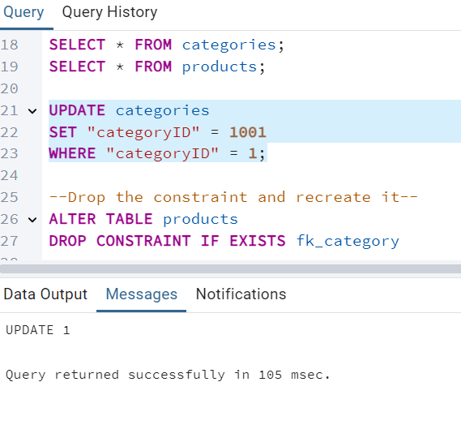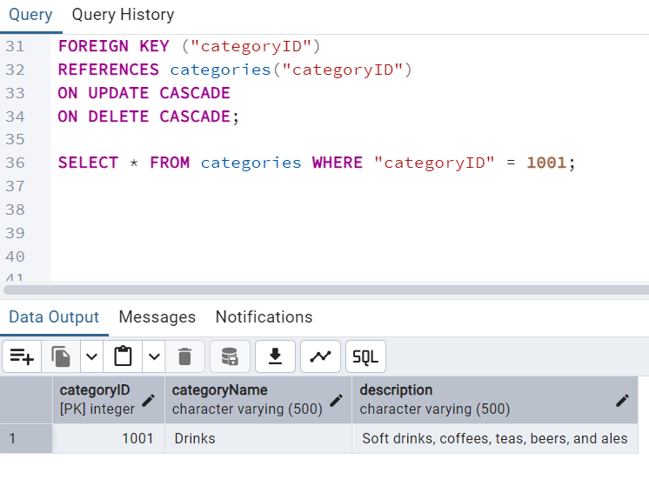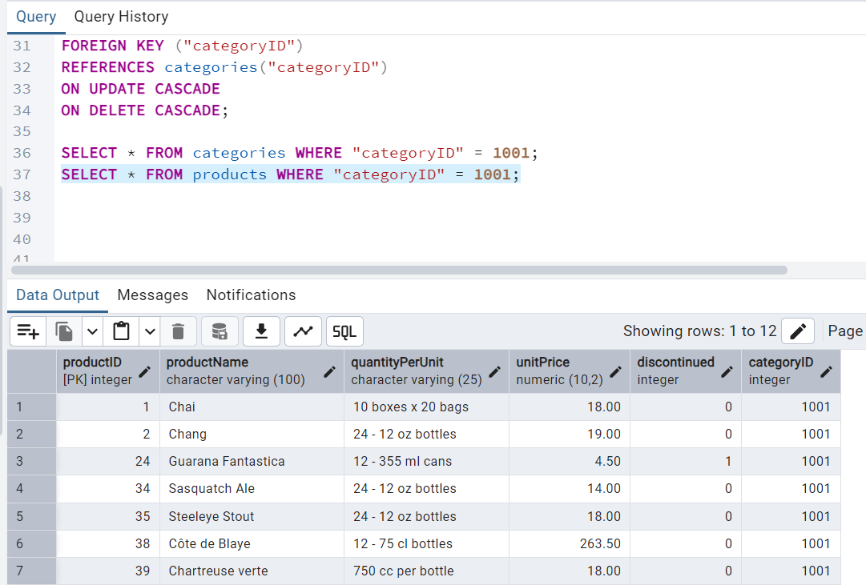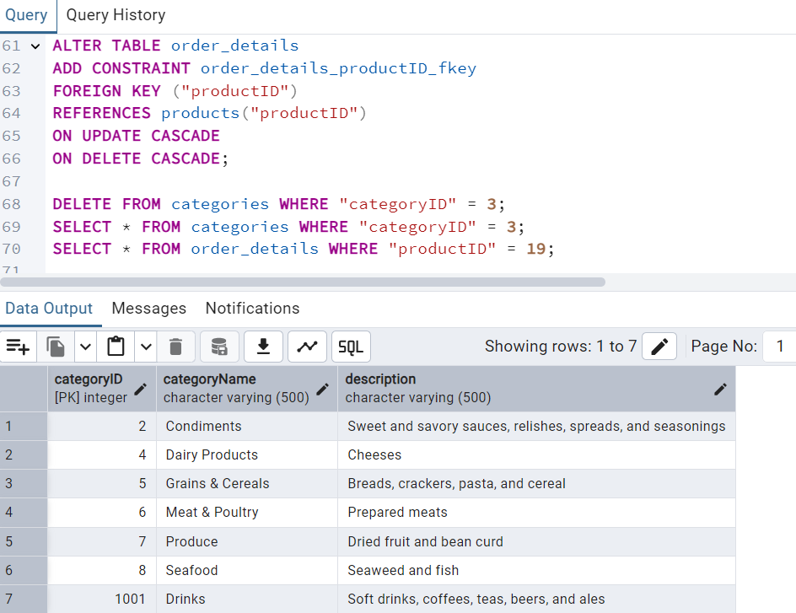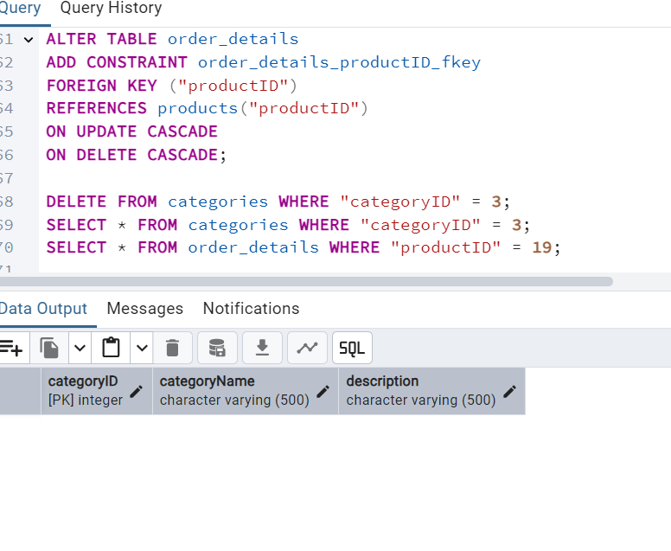

4)      Delete the customer = “VINET”  from customers. Corresponding customers in orders table should be set to null (HINT: Alter the foreign key on orders(customerID) to use ON DELETE SET NULL)

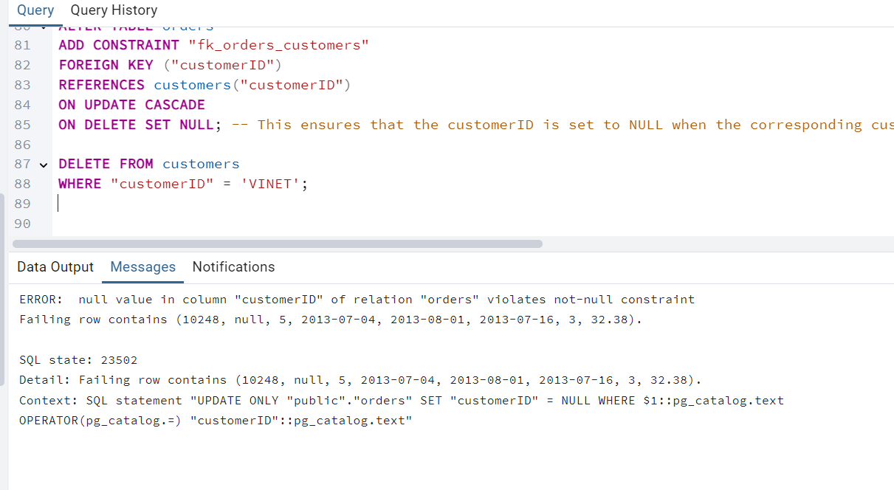

CustomerID Set NOT NULL, after dropping NOT NULL Deleted the customerID = “VINET”  
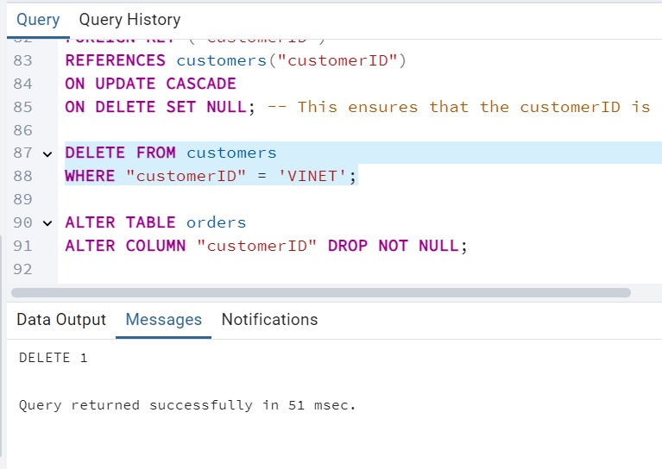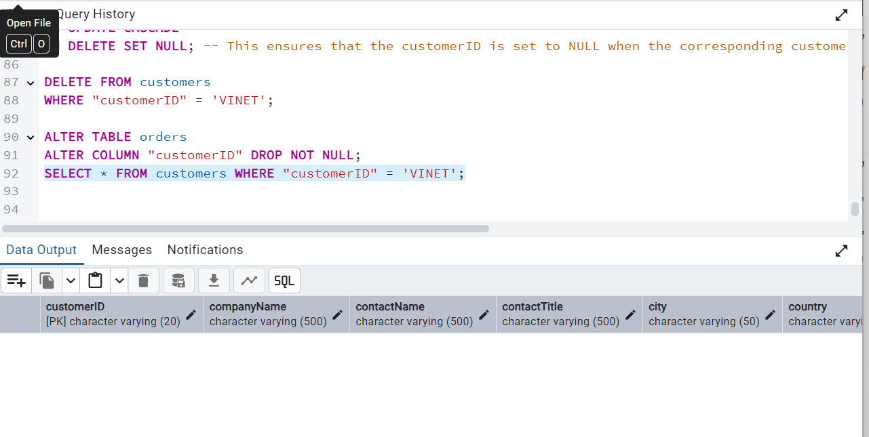

5)      Insert the following data to Products using UPSERT:  
product_id = 100, product_name = Wheat bread, quantityperunit=1,unitprice = 13, discontinued = 0, categoryID=5  
product_id = 101, product_name = White bread, quantityperunit=5 boxes,unitprice = 13, discontinued = 0, categoryID=5  
product_id = 100, product_name = Wheat bread, quantityperunit=10 boxes,unitprice = 13, discontinued = 0, categoryID=5  
(this should update the quantityperunit for product_id = 100)

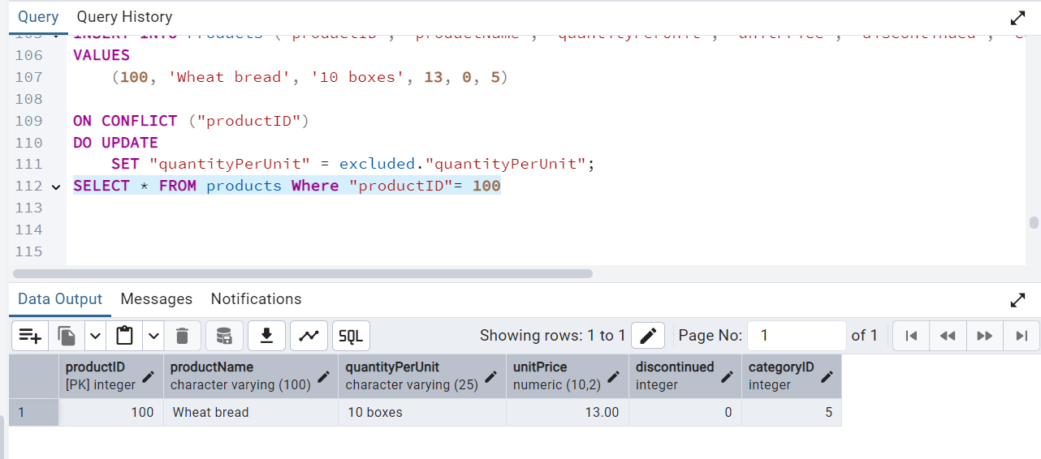

6)      Write a **MERGE query**:  
Create **temp table with name:**  ‘updated_products’ and insert values as below:

|  |  |  |  |  |  |
| --- | --- | --- | --- | --- | --- |
| productID | productName | quantityPerUnit | unitPrice | discontinued | categoryID |
| 100 | Wheat bread | 10 | 20 | 1 | 5 |
| 101 | White bread | 5 boxes | 19.99 | 0 | 5 |
| 102 | Midnight Mango Fizz | 24 - 12 oz bottles | 19 | 0 | 1 |
| 103 | Savory Fire Sauce | 12 - 550 ml bottles | 10 | 0 | 2 |

* Update the price and discontinued status for from below table ‘updated_products’ only if there are matching products and updated_products .discontinued =0
* If there are matching products and updated_products .discontinued =1 then delete
* Insert any new products from updated_products that don’t exist in products only if updated_products .discontinued =0.

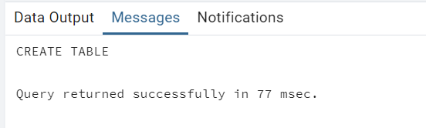

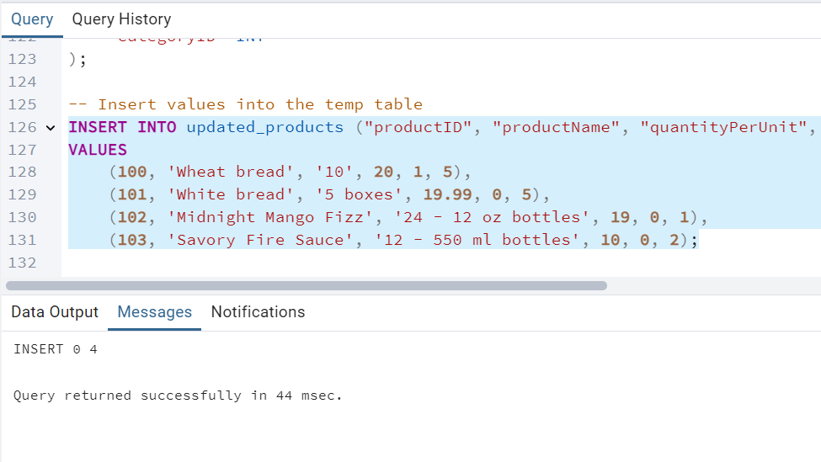  
  
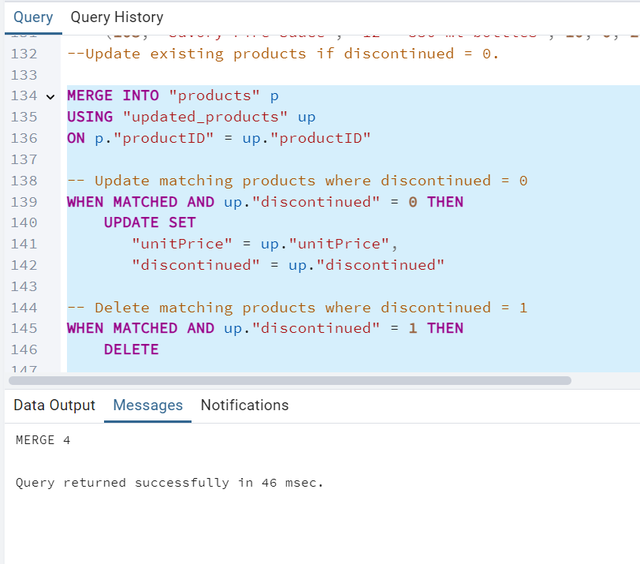

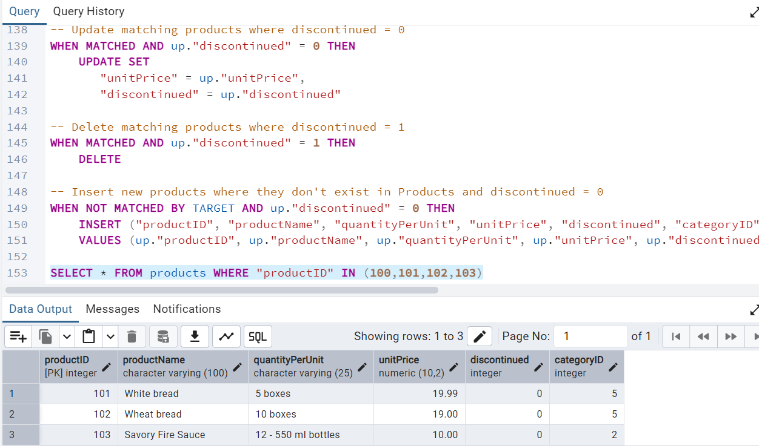

7)      List all orders with employee full names. (Inner join)

